Date: February 2016

Precise Semantics of UML State Machines (PSSM)

Initial Submission
In response to the Precise Semantics of UML State Machines RFP (ad/2015-03-02)
__________________________________________________
OMG Document Number: ad/2016-02-xx
Machine Readable File(s):

_________________________________________________
Submitted by:
BAE Systems
Model Driven Solutions
No Magic, Inc.
Supported by:
Airbus Group
Commissariat á l'Energie Atomique et Alternatives (CEA)
LieberLieber Software
Simula Research Laboratory

Copyright © 2016 Airbus Group
Copyright © 2016 BAE Systems
Copyright © 2016 Commissariat á l'Energie Atomique et Alternatives (CEA)
Copyright © 2016 Data Access Technologies, Inc. (Model Driven Solutions)
Copyright © 2016 LeiberLeiber Software
Copyright © 2016 No Magic, Inc.
Copyright © 2016 Simula Research Laboratory

COPYRIGHT WAIVER
Each of the entities listed above: (i) grants to the Object Management Group, Inc. (OMG) a nonexclusive, royalty-free, paid up, worldwide license to copy and distribute this document and to modify this document and distribute copies of the modified version, and (ii) grants to each member of the OMG a nonexclusive, royalty-free, paid up, worldwide license to make up to fifty (50) copies of this document for internal review purposes only and not for distribution, and (iii) has agreed that no person shall be deemed to have infringed the copyright in the included material of any such copyright holder by reason of having used any OMG specification that may be based hereon or having conformed any computer software to such specification.

Table of Contents

0 Submission Introduction iv
0.1 Overview iv
0.2 Submitters iv
0.3 Mandatory Requirements iv
0.4 Non-Mandatory Features vii
0.5 Issues To Be Discussed viii
1 Scope 1
2 Conformance 1
2.1 General 1
2.2 Conformance Levels 1
2.2.1 PSSM-only Conformance 1
2.2.2 Joint PSSM and PSCS Conformance 2
2.3 Genericity of the Execution Model 2
3 Normative References 3
4 Terms and Definitions 3
5 Symbols 4
6 Additional Information 5
6.1 Changes to Adopted OMG Specifications 5
6.2 Acknowledgments 5
7 Abstract Syntax 6
7.1 Overview 6
7.2 Values 6
7.2.1 Overview 6
7.2.2 Expressions 6
7.2.2.1 Overview 6
7.2.2.2 Class Descriptions 6
7.3 Structured Classifiers 6
7.3.1 Overview 6
7.3.2 Classes 6
7.4 State Machines 6
7.4.1 Overview 6
7.4.2 Behavior State Machines 6
7.4.3 State Machine Redefinition 6
8 Execution Model 7
8.1 Overview 7
8.2 Loci 7
8.2.1 Overview 7
8.2.2 Class Descriptions 7
8.3 Values 7
8.3.1 Overview 7
8.3.2 Expressions 7
8.3.2.1 Overview 7
8.3.2.2 Class Descriptions 7
8.4 Structured Classifiers 7
8.4.1 Overview 7
8.4.2 Classes 7
8.5 State Machines 7
8.5.1 Overview 7
8.5.2 Behavior State Machines 7
8.5.3 State Machine Redefinition 7
9 Test Suite 8
9.1 Overview 8
9.1.1 UML Semantics Requirements 8
9.1.2 Test Suite Organization 8
9.1.3 Test Coverage and Limits 8
9.1.4 Constraint on Vendors implementing the Semantic Model 8
9.2 Utilities 8
9.2.1 Architecture 9
9.2.1.1 Relation with UML testing profile 9
9.2.1.2 Base Semantic Test 9
9.2.1.2.1 Tester 10
9.2.1.2.2 Target 11
9.2.1.2.3 SemanticTest 11
9.2.1.3 Semantic Test and Test Suite 13
9.2.1.3.1 SemanticTestSuite 13
9.2.2 Protocol 15
9.2.2.1 Synchronization 16
9.2.2.1.1 Start 16
9.2.2.1.2 End 16
9.2.2.1.3 TestEnd 17
9.2.2.2 Stimulation sequence 17
9.2.3 Tracing 17
9.3 Tests 18
9.3.1 Behaviors 18
9.3.1.1 Overview 18
9.3.1.2 Test Behavior 001 18
9.3.1.3 Test Behavior 002 18
9.3.1.4 Test Behavior 004 18
9.3.2 Transitions 18
9.3.3 Region 18
9.3.4 Event 18
9.3.5 Entering 18
9.3.6 Exiting 18
9.3.7 Exit 18
9.3.8 Entry 18
9.3.9 Choice 18
9.3.10 Other Tests 18
A Protocol State Machines 19
A.1 Overview 19
A.2 Abstract Syntax 19
A.3 Semantics 19
A.3.1 Controlled Events 19
A.3.2 Protocol States Configuration 20
A.3.3 Protocol Violation 20

Submission Introduction

Overview
This is OMG document ad/2016-92-xx, entitled Precise Semantics of UML State Machines, which may be abbreviated “PSSM”. It is submitted in response to the RFP for Precise Semantics of UML State Machines (PSSM) (ad/2015-03-02). Similarly to previous Executable UML specifications on the Semantics of a Foundational Subset for Executable UML Models (fUML) and the Precise Semantics of UML Composite Structures (PSCS), the proposed PSSM specification defines the subset of the UML abstract syntax relevant to UML state machines, as an extension of the fUML abstract syntax subset (see Clause 7), and an operational semantics for that subset, as an extension to the fUML/PSCS execution model (see Clause 8). In addition, as required in the RFP, the proposed specification includes a suite of tests that may be used to validate the conformance of an execution tool to the specification (see Clause 9).

Submitters
The following OMG member organizations (with the given contact individuals) are jointly submitting this proposed specification.
- BAE Systems (Jeffery Smith, jeffrey.smith5@baesystems.com)
- Model Driven Solutions (Ed Seidewitz, ed-s@modeldriven.com)
- No Magic, Inc. (Nerijus Jankevicius, nerijus@nomagic.com)
The following OMG members organizations are supporters of and contributors to this proposed specification, but not formal submitters. All have licensed any contributed material as necessary to one of the formally submitting organizations.
- Airbus
- Simula Research Laboratory
- LieberLieber
- CEA

Mandatory Requirements
The table below describes how this proposed specification responds to each of the mandatory requirements of the PSSM RFP.
Requirement | Response
6.5.1a Proposals shall provide precise semantics for UML behavior state machines, including the following underlying metaclasses:
- FinalState
- Pseudostate (all kinds)
- Region (except for redefinition)
- State (except for redefinition and submachine states)
- StateMachine (except state machine extension)
- Transition (except for redefinition), including completion transitions (with no triggers) and transitions with triggers for the following kinds of events:
- Call Event
- Signal Event
- Vertex
6.5.1b Proposals shall define how data associated with event occurrences shall be accessed by transition guards and passed to transition effect behaviors and state behaviors during the process of event dispatching and transition triggering.
6.5.1c The precise semantics shall cover at least the cases of the standalone execution of state machines (i.e., with no other behaviored classifier as context) and state machines used as classifier behaviors of active classes.
6.5.1d The precise semantics for state machines shall include the meaning of specifying a port on a trigger in a state machine. The proposed semantics for this (and any other potential touch points with UML composite structure as identified by submitters) shall be consistent with the semantics of composite structures as defined in the Precise Semantics of UML Composite Structures (PSCS) specification. This consistency shall be such that there would be no conflict in a tool conforming to both the proposed state machine semantics and PSCS. However, proposals shall not require that a tool necessarily formally conform to the entire PSCS specification in order to conform to the precise semantics for state machines.
6.5.1e The semantic description shall establish explicit relationships with fUML, for example by specifying a precise formal model transformation from the metaclasses listed above to metaclasses which are part of the fUML subset and/or by extending the fUML execution model, for example with appropriate visitor classes. Whatever the way the execution semantics are actually specified, proposals shall be readable as if they are additions to fUML semantics, rather than separate specifications.
6.5.1f Proposals shall extend the base semantics of fUML with specific axioms for UML state machines only if necessary. These new axioms shall have explicit relationships with existing axioms of fUML base semantics. These axioms shall be expressed in Common Logic Interchange Format (as was done for fUML). Submitters shall demonstrate, through manual or automated means, that the new axioms are consistent with fUML axioms.
6.5.2a Proposals shall precisely identify any allowed semantic variabilities. These semantic variabilities shall be in the scope of semantic variabilities allowed by UML state machines (potentially including only a subset of allowed UML semantic variabilities, as was the case for fUML).
6.5.2b Proposals shall define rules for defining semantic variants, where a semantic variant is an internally consistent set of values for the different semantic variabilities allowed from requirement 6.5.2.a.
6.5.3a Proposals shall conform to the current version of the UML 2 metamodel and notation.
6.5.3b Proposals shall use the current version of the fUML specification.
6.5.3c Proposals shall use the current version of the PSCS specification.
6.5.3d For any extension to the fUML base semantics using CLIF, proposals shall conform to the current version of the ISO Common Logic standard.
6.5.4a Proposals shall provide a suite of test cases that can demonstrate conformance to this specification, as described in section 6.2.
6.5.4b Proposals shall demonstrate the coverage by the test suite of all proposed state machine semantic functionality and the traceability of each test case to specific required functionality.

Non-Mandatory Features
The following table describes whether and how this proposed specification provides the non-mandatory features listed in the PSSM RFP.
Feature | Response
6.6.1 Proposals may provide precise semantics of submachine states, as represented by the A_submachineState_submachine meta-association and including the ConnectionPointReference metaclass.
6.6.2 Proposals may provide precise semantics of UML protocol state machines, including the following underlying metaclasses:
- ProtocolConformance
- ProtocolStateMachine
- ProtocolTransition
6.6.3 Proposals may provide precise semantics for state machine redefinition, as represented by the following meta-associations:
- A_extendedRegion_region
- A_extendedStateMachine_stateMachine
- A_redefinedState_state
- A_redefinedTransition_transition
- A_redefinitionContext_region
- A_redefinitionContext_state
- A_redefinitionContext_transition
6.6.4 Proposals may provide precise semantics for asynchronous operation calls (which are not currently allowed in fUML). If provided, such semantics should include the handling of asynchronous calls both by call event triggers in state machines and by operation methods. Proposals may additionally provide semantics for accepting call events in activities, as covered by the AcceptCallAction and ReplyAction metaclasses.
6.6.5 Proposals may provide precise semantics for triggers with ChangeEvents.
6.6.6 Proposals may use the Action language for Foundational UML (Alf) as a concrete syntax for specifying the execution semantics of state machines.

Issues To Be Discussed
- Proposals shall discuss how state machines may be used to specify the behavior of passive classes.

Background and Rationale
The use of state machines for describing the behavior of instances of passive object classes can be found in several UML tools, notably in Rhapsody and RSA RTE (both from IBM). In fact, the original 1.x series of UML specifications explicitly discusses the case of passive state machines (e.g., section 2.12.4.7 in the UML 1.3 specification [1]). In particular, it mentions a possible means for ensuring preservation of run-to-completion semantics for passive classes whose behavior is specified via state machines.
To help us understand how the behavior of passive classes can be described using state machines, it is useful to recall that an essential characteristic of state machine behaviors is that a response to a particular stimulus (e.g., a call event occurrence) depends on the object’s history; that is, the nature and order of preceding stimuli received by that object. In active class state machines, this information is captured concisely by the current state of an object’s classifier behavior. However, when dealing with passive objects, which do not have a classifier behavior, this means that, in the general case, each method of the class needs to include a conditional branch to handle the different responses based on some internal value that, in effect, represents the history of the object.
Consider, for example, the simplest case of a Stack class shown in the diagram below. Note that the response to a “pop” operation will depend on whether the stack is empty or not. Similarly, assuming that the stack is of limited capacity, the response to a “push” operation will differ when the stack is full compared to when it is not full.

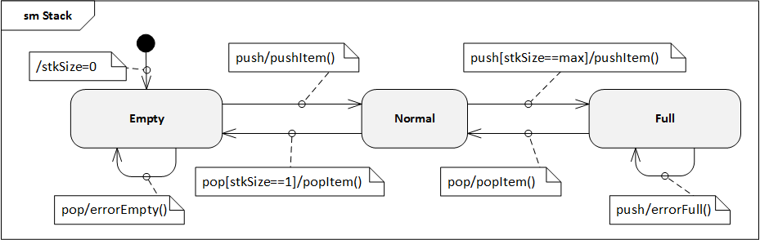
Of course, this can be coded explicitly by defining a suitable local variable of the object (e.g., “stack size”) and using appropriate action language conditional statements. But, this not only obscures the true nature of the behavior in question, but, because it relies on relatively low-level (i.e., “manual”) coding it, is also more error prone and requires more effort by the modeler. This approach becomes increasingly more problematic as the complexity of the behavior grows.
Hence, the motivations behind supporting state machine specifications of passive class behaviors are to reduce the burden on the modeler, to more clearly describe an object’s behavior using a higher-level formalisms, and to increase both reliability and productivity.

Proposed Approach
To avoid gratuitous differences from the familiar semantics of active state machines, the general strategy taken is to be fully consistent with those semantics wherever possible. Note that this proposal covers both passive classes as well as stand-alone passive state machines (which are, after all, classes as well).
The core idea behind the approach is straightforward: map the state machine specification into an equivalent set of behavioral fragments and conditional statements distributed across the appropriate methods. For example, all three transitions triggered by the “pop” call event in the Stack example above, would be mapped to appropriate conditional statement cases of a single “pop” operation method. The control variable of such a statement would correspond to the current state of the state machine. This is illustrated by the following pseudocode for the method of the “pop” operation:
operation pop(): Item {
case (state) {
'Empty': errorEmpty();
'Normal': if (stkSize == 1) then
{popItem();
nextState('Empty');}
else
popItem();
'Full': {popItem();
nextState('Normal');}
};
}
Furthermore, any action associated with the initial transition would be mapped to the method of the class constructor.
Of course, in addition to the lack of a classifier behavior, one key difference between active and passive class semantics is in how the transition triggering mechanism works. For active classes, triggering is realized by a dedicated scheduling and dispatch mechanism, which is external to the state machine instance. Among other responsibilities, this mechanism also ensures that run-to-completion semantics are enforced. In contrast, no such mechanism exists for passive classes; the methods of a passive class are executed synchronously when some calling behavior invokes the corresponding operation. Consequently, if two or more concurrently executing behaviors make overlapping calls to the same passive object, there is a possibility of concurrency conflicts that would violate the run-to-completion semantics. (Note that this can occur even if all of the operations of the passive class are declared as “guarded”, since that only prevents a given operation being invoked concurrently. However, it would still be possible to concurrently invoke two or more different operations of the passive class.)
Therefore, to ensure run-to-completion semantics of a passive class state machine, it is proposed that for any passive class whose behavior is defined by a state machine, at most one operation call can be executed (to completion) at a time. Alternatively, this could be made a configurable option. However, that would lead to unsafe and error prone designs, and would violate one of the core semantic tenets of UML state machines.
- Proposals shall address issues with the UML abstract syntax involved in the specification of the accessing and passing of data from event occurrences, as required in 6.5.1b.
TBD
- Proposals shall discuss the relationship of the proposed precise semantics for UML state machines to the causality model defined for the UML Profile for MARTE.
TBD
- Proposals shall discuss the relationship of the proposed precise semantics for UML state machines to the specification of a state machine ontology and, particularly, to the integration approach of OntoIOP.
TBD
- Proposals shall discuss the relationship of the proposed precise semantics for UML state machines to the semantics defined for state machines in the W3C State Chart XML (SCXML) specification.
TBD
- Proposals shall describe a proof of concept implementation that can successfully execute tests from the conformance test suite, without violating any tests from the PSCS conformance test suite.
CEA has developed a prototype proof of concept implementation of the execution model defined in Clause 8 of this specification. It is integrated to the Papyrus model execution framework Moka as a specific execution engine. Papyrus and Moka tooling are based on the Eclipse implementation of the UML 2.5 metamodel. Therefore, models that can be interpreted by the prototype must conform to this metamodel implementation.
The execution model implemented by the prototype is built on top of the one defined to capture the PSCS semantics. The prototype is able to execute any model conforming to subset that is covered both by fUML and PSCS. In addition it also able to execute models including syntax elements that are covered by the subset of behavior state machines identified in this specification (see 7.4.2).
In order to verify that the PSSM prototype does not violate the assertions defined for PSCS we proceeded in the following manner:
- The PSCS test suite was executed by using only the implementation for the PSCS execution model. This execution enabled us to produce the reference trace.
- The PSCS test suite was then executed with the prototype implementation of PSSM. This execution enabled us to produce the trace that need to be compared to the reference.
The difference check that was performed between the two traces did not highlighted any difference. To conclude, we can say that if the traces are equal then PSSM prototype does not violate the semantics captured for PSCS.

Scope
This specification is an extension of the Semantics of a Foundational Subset for Executable UML Models standard (known as “Foundational UML” or “fUML”) [fUML] that defines the execution semantics for UML state machines. Syntactically, this specification extends fUML by with a (large) subset of the abstract syntax of state machines as given in the OMG Unified Modeling Language specification [UML] (Clause 14, for UML 2.5 and later). Semantically, this specification extends the fUML execution model in order to specify the operational execution semantics of the state machine abstract syntax subset.
The semantic model defined in this specification is actually an extension of the model from the Precise Semantics of UML Composite Structures (PSCS) standard [PSCS], which is itself an extension of fUML. This is done in order to ensure that the semantics given in this specification are compatible with the extensions defined in PSCS and to allow for the definition of the semantics of triggers with an “onPort” reference. However, this latter feature is the only point for which the semantics of state machines presented here depends in any way on the PSCS semantic extensions, and it is possible for an execution tool to conform to this specification without also conforming to the PSCS specification (see Clause 1).

Conformance

General
This specification defines a precise semantics for a subset of UML 2 concepts associated with the notion of a state machine. This definition is based on the Foundational UML Subset (henceforth referred to as “fUML” in the remainder of this clause), which is specified in [fUML]. Hence, except where explicitly noted in this clause, the definitions, interpretations (meaning), and types of conformance and related terms in this specification fully match their corresponding definitions, interpretations, and types in fUML. Thus, as in fUML, conformance to this specification has two aspects:
- Syntactic Conformance – A conforming model must be restricted to the abstract syntax subset defined in Clause 7 of this specification.
- Semantic Conformance – A conforming execution tool must provide execution semantics for a conforming model consistent with the semantics specified in Clause 8 of this document.

Conformance Levels
The semantic model in Clause 8 is specified as an extension to the semantic model given in [PSCS]. However, the only point at which the semantics given in this specification actually depend on the PSCS semantics is for triggers with an “onPort” reference (see TBD). There are two levels of conformance defined for this specification, depending on whether an execution tool conforms only to PSSM or conforms to PSSM and PSCS, including the semantics for triggers with “onPort”. Both of these have syntactic and semantic aspects, as specified in the following subclauses.

PSSM-only Conformance
- Syntactic Conformance – A conforming model must be restricted to the abstract syntax subset defined in Clause 7 of this specification, with the further restriction that triggers must not have onPort references.
Note. The abstract syntax subset defined in Clause 7 is a superset of the subset defined in [fUML]. Thus, every syntactically conforming fUML model is also a syntactically conforming PSSM model.
- Semantic Conformance – A conforming execution tool must provide execution semantics for a conforming model consistent with the semantics specified in Clause 8 of this specification. Demonstrating semantic conformance to fUML (as defined in Clause 2 of [fUML] and passing all the tests of the test suite in Clause 9 of this specification, except for this related to onPort (see TBD), is sufficient to demonstrate semantic conformance at this level.

Joint PSSM and PSCS Conformance
- Syntactic Conformance – A conforming model must be restricted to the abstract syntax subset defined by the union of the subset defined Clause 7 of this specification and the subset defined in Clause 7 of [PSCS]. The model shall satisfy all constraints as specified in this specification and in [PSCS].
- Semantic Conformance – A conforming execution tool must provide execution semantics for a conforming model consistent with the semantics specified in Clause 8 of this specification and the semantics specified in Clause 8 of [PSCS]. Demonstrating semantic conformance to fUML (as defined in Clause 2 of [fUML]) and passing all the tests of the test suite in Clause 9 of this specification and all the tests in Clause 9 of [PSCS] is sufficient to demonstrate semantic conformance at this level.

Genericity of the Execution Model
To support a variety of different execution paradigms and environments, the specification of the execution model incorporates a degree of genericity. This is achieved in two ways: (1) by leaving some key semantic elements unconstrained, and (2) by defining explicit semantic variation points. A particular execution tool can then realize specific semantics by suitably constraining the unconstrained semantic aspects and providing specifications for any desired variation at semantic variation points.
The semantic areas that are not explicitly constrained by the execution model in this specification are the same as the ones defined in subclause 2.3 of [fUML]. Different execution tools may semantically vary in these areas in executing the same model, while still being conformant to the semantics specified by the execution model in this specification. Additional semantic specifications or constraints may be provided for a specific execution tool in these areas, so long as it remains, overall, conformant to the execution model. For instance, a particular tool may be limited to a single centralized time source such that all time measurements can be fully ordered.
In contrast to the above areas, the items below are explicit semantic variation points. That is, the execution model as given in this specification by default fully specifies the semantics of these items. However, it is allowable for a conforming execution tool to define alternate semantics for them, so long as this alternative is fully specified as part of the conformance statement for the tool.
- The semantic variation points defined in subclause 2.3 of [fUML]. Note, however, that the default event dispatching strategy defined for fUML is replaced by the default strategy given in subclause 8.4.1.2.1 of [PSCS].
- In addition, this specification introduces one new semantic variation point and a corresponding default strategies for it: the method for selecting which transitions of a state machine (if any) will fire in response to a given event occurrence.
If a conforming execution tool wishes to implement a semantic variation in one of the above areas, then a specification most be provided for this variation via a specialization of the appropriate execution model class as identified above. This specification must be provided as a fUML model in the “base UML” subset interpretable by the base semantics of Clause 10 of [fUML]. Further, it must be defined in what cases the variation is used and, if different variants may be used in different cases, when each variant applies, and/or how what variant to use, is to be specified in a conforming model accepted by the execution tool.

Normative References
The following normative documents contain provisions which, through reference in this text, constitute provisions of this specification. For versioned references, subsequent amendments to, or revisions of, any of these publications do not apply.
[fUML] Semantics of a Foundational Subset for Executable UML Models (fUML), Version 1.2.1, http://www.omg.org/spec/FUML
[PSCS] Precise Semantics of UML Composite Structures (PSCS), Version 1.0, http://www.omg.org/spec/PSCS
[UML] OMG Unified Modeling Language (OMG UML), Version 2.5, http://www.omg.org/spec/UML
[UTP] UML Testing Profile.
Note. The semantics of state machines given in this specification are intended to be consistent with the syntax and semantics given in UML 2.5. However, fUML and PSCS are currently formally based on UML 2.4.1 (though PSCS incorporates UML 2.5 clarifications of the semantics of composite structures). For consistency, it is expected that the normative references given here for fUML and PSCS will be updated to versions consistent with UML 2.5, as soon as these become available.

Terms and Definitions
For the purposes of this specification, the following terms and definitions apply.

Base Semantics
A definition of the execution semantics of those UML constructs used in the execution model, using some formalism other than the execution model itself. Since the execution model is a UML model, the base semantics are necessary in order to provide non-circular grounding for the execution semantics defined by the execution model. The base semantics provide the “meaning” for the execution of just those UML constructs used in the execution model. The execution model then defines the “meaning” of executing any UML model based on the full foundational subset. Any execution tool that executes the execution model should reproduce the execution behavior specified for it by the base semantics. (The base semantics for this specification are as specified in [fUML].)

Behavioral Semantics
The denotational mapping of appropriate language elements to a specification of a dynamic behavior resulting in changes over time to instances in the semantic domain about which the language is making statements.

Execution Model
A model that provides a complete, abstract specification to which a valid execution tool must conform. Such a model defines the required behavior of a valid execution tool in carrying out its function of executing a UML model and therefore provides a definition of the semantics of such execution.

Execution Semantics
The behavioral semantics of UML constructs that specify operational action over time, describing or constraining allowable behavior in the domain being modeled.

Execution Tool
Any tool that is capable of executing any valid UML model that is based on the abstract syntax subset defined in this specification and expressed as an instantiation of the UML 2 abstract syntax metamodel. This may involve direct interpretation of UML models and/or generation of equivalent computer programs from the models through some kind of automated transformations. Such a tool may also itself be concurrent and distributed.

Static Semantics
Possible context sensitive constraints that statements of a language must satisfy, beyond their base syntax, in order to be well-formed.

Structural Semantics
The denotational mapping of appropriate language elements to instances in the semantic domain about which the language makes statements.

Syntax
The rules for how to construct well-formed statements in a language or, equivalently, for validating that a proposed statement is actually well-formed.

Symbols
There are no symbols or abbreviated terms necessary for the understanding of this specification.

Additional Information

Changes to Adopted OMG Specifications
TBD

Acknowledgments
The following people directly contributed to the development of this specification.
- Yves Bernard, Airbus
- Nerijus Jankevicius, No Magic
- Ed Seidewitz, Model Driven Solutions
- Bran Selic, Simula Research Laboratory
- Daniel Siegl, LieberLieber
- Jeffery Smith, BEA Systems
- Jérémie Tatibouet, CEA

Abstract Syntax

Overview

Values

Overview

Expressions

Overview

Class Descriptions

Structured Classifiers

Overview

Classes

State Machines

Overview

Behavior State Machines

State Machine Redefinition

Execution Model

Overview

Loci

Overview

Class Descriptions

Values

Overview

Expressions

Overview

Class Descriptions

Structured Classifiers

Overview

Classes

State Machines

Overview

Behavior State Machines

State Machine Redefinition

Test Suite

Overview
The PSSM specification is delivered with a test suite. This test suite is designed as a UML model. It captures a set of tests cases that when executed enables us to assess the semantics that is captured within the semantic model for UML state machines that is presented in Clause 8.

UML Semantics Requirements
The definition of the test suite is strongly coupled to the semantics requirements that were identified within the UML chapter related to state machines semantics (see annex XX). Indeed each test case verify (or not) one particular requirement. A requirement takes the form of textual description of particular part of the semantics related to state machines. A test case is defined as an executable UML model that assesses this particular part of the semantics. Each time a test will be presented in 9.3, its related requirement will also be reminded.

Test Suite Organization
The test suite is separated into two parts. The first one defines the abstract architecture of a test case. This architecture is specialized (in the UML sense) for each test case. A detailed presentation of this part of the test suite model is given in 9.2.
The second part of the test suite defines a set of packages where each package refers to a particular test category. As an example a test category in the test suite captures all tests cases related to transition semantics. Each test case in this category asserts a specific part (identified in the requirements) of the transition semantics.

Test Coverage and Limits
The purpose of having a strong coupling between the semantics requirements for state machines is to be able (as in usual software development) to identify quickly and precisely what is covered by the semantic model in terms of semantics and what is currently not covered. Statistics and limitations about current coverage of UML state machines semantics are presented in section [REF].

Utilities
One objective of the PSSM test suite is to define a base architecture to simplify the definition of executable tests cases. This architecture (structure and behavior) is presented in 9.2.1. The communications that take place between the different elements of the architecture are presented in 9.2.2. Finally, 9.2.3 explains the process of generating a trace that capture information about the state machine execution. This trace is used to compare the execution expected for the state machine against the trace actually generated at execution time.

Architecture
This subclause presents the architecture that was defined to describe test cases to assess PSSM semantic model. In 9.2.1.1, concepts provided by UTP (UML Testing Profile) that are reused in the context of the test suite architecture are identified. In 9.2.1.2, the structure and the behavior of a base semantic test are presented. Finally, 9.2.1.3 identifies the structure of the semantic test container as well its behavior.

Relation with UML testing profile
The UML testing profile was built to provide “a standardized language based on OMG's Unified Modeling Language for designing, visualizing, specifying, analyzing, constructing, and documenting the artifacts commonly used in and required for various testing approaches, in particular model-based testing (MBT) approaches” [UTP].
The base architecture of the PSSM test suite is inspired by concepts identified by the UML testing profile. These concepts are:
- TestComponent: “Test components are part of the test environment and are used to communicate with the system under test (SUT) and other test components. The main function of test components is to drive a test case by stimulating the system under test through its provided interfaces and to evaluate whether the actual responses of the system under test comply with the expected ones.” (see subclause 8.2.2.2 of [UTP] to read the complete description of this concept).
- TestCase: “A test case is a behavioral feature or behavior specifying tests. A test case specifies how a set of test components interact with an SUT to realize a test objective. Test cases are owned by test contexts, and therefore have access to all parts of the test configuration, other global variables (e.g., data pools, etc.) or further behavioral features (e.g., auxiliary methods). A test case always returns a verdict.” (see subclause 9.2.2.4 of [UTP] to read the complete description of this concept).
- TestContext: “A test context acts as a grouping mechanism for a set of test cases. The composite structure of a test context is referred to as test configuration. The classifier behavior of a test context may be used for test control” (see subclause 8.2.2.3 of [UTP] to read the complete description of this concept).
The next subclause shows how these concepts are used in the context of the definition of the abstract architecture of a test.

Base Semantic Test
Figure 9.1 illustrates the architecture of an abstract semantic test.

Tester
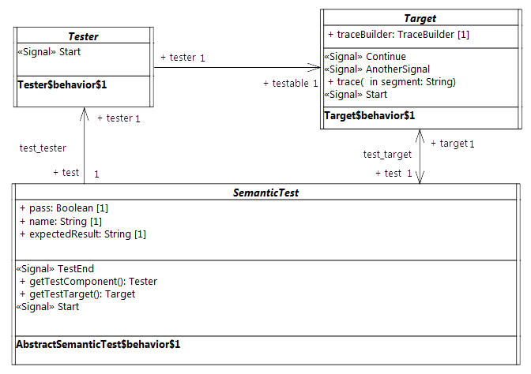Figure 9.1 - Architecture of an abstract semantic test

Description
The tester is an abstract active class which encodes in its classifier behavior the stimulation sequence (i.e, a set of events) that will be sent to the target (i.e., the system under test).
Note that this role matches to what is intended for a TestComponent in UTP. This class has the stereotype “TestComponent” applied.

Association Ends
- testable: Target [1] – The SUT (System Under Test) to which the stimulation sequence is sent.
- test: SemanticTest [1] – The test case which controls the tester.

Receptions
- Start – A tester can receive Start signal

Classifier Behavior
The classifier behavior of the abstract tester is empty. Specializations are intended to provide a new classifier behavior which will encode the user defined stimulation sequence.

Target

Description
The target defines the system under test. Specializations of this class have to provide their classifier behaviors specified as a state machine.
The target receives the stimulation sequence produced by the tester. The dispatching of the events will enable transitions of the state machine playing the role of a classifier behavior to be triggered.
All along its execution the state machine generates an execution trace. This trace is stored by the target and finally provided as the result of the execution to the test which controls the target.

Attributes
- traceBuilder: TraceBuilder [1] – Each test target owns a trace builder. It enables the classifier behavior of a target to build a trace all along its execution.

Association Ends
- test: SemanticTest [1] - The test case which controls the target.

Operations
- trace(in segment: String[1]) – The operation enables the addition of “segment” (i.e., a new part) to the execution trace. It can be called at any time in the classifier behavior of the target to capture information relative to the executed state machine.

Receptions
- Start – The target is able to receive Start signals
- Continue – The target is able to receive Continue signals
- AnotherSignal – The target is able to receive AnotherSignal signals.

Classifier Behavior
The classifier behavior of the abstract Target is empty. All specializations are intended to provide a new classifier behavior which will be the state machine whose execution is performed by the execution model defined for PSSM.

SemanticTest

Descriptions
A SemanticTest is the main artifact of a semantic test case. It is in charge of instantiating and controlling the tester and the target (i.e. the SUT). When the execution of the SUT is done then the execution trace that was produced is provided to the semantic test case for analysis. If the trace matches one of the expected trace for the executed state machine the test pass otherwise it fails.
The classifier behavior of a semantic test has the TestCase stereotype applied.

Attributes
- name: String [1] – The name of the test case name.
- pass: Boolean [1] – The current status (pass or fail) of the test.
- expectedResult: String [1] – The execution trace that is expected for SUT.

Operations
- getTestComponent(): Tester – Abstract operation which returns an instance of the tester controlled by the semantic test whose classifier has been started. This operation is intended to be redefined by specializations of SemanticTest.
- getTestTarget(): Target – Abstract operation which returns an instance of the target controlled by the semantic test whose classifier has been started. This operation is intended to be redefined by specializations of SemanticTest.
- assert(in trace: String[1]) – This operation updates the value of the attribute “pass” by comparing the trace given as a parameter to the expected execution trace known by the semantic test.

Receptions
- Start – The semantic test is able to receive Start signals.
- TestEnd – The semantic test is able to receive TestEnd signals.

Classifier Behavior
The classifier behavior of a semantic test is defined as UML activity (which conforms to the fUML subset). It is presented in Figure 9.2.
The principle of the behavior is the following:
- When the classifier behavior starts it blocks waiting for the dispatching of a Start signal
- On the reception of the Start signal it creates and instantiates both a the tester and the target.
  - The links (instances of associations) are created.
  - The tester and the target receive a Start signal.
  - The semantic test finally blocks again waiting for the dispatching of a TestEnd signal.
- When the TestEnd signal is received then it computes the verdict of the test and notifies the test suite that controls it.
Note that specializations of a semantic test are not intended to override the dynamic that is captured in this classifier behavior.

Semantic Test and Test Suite
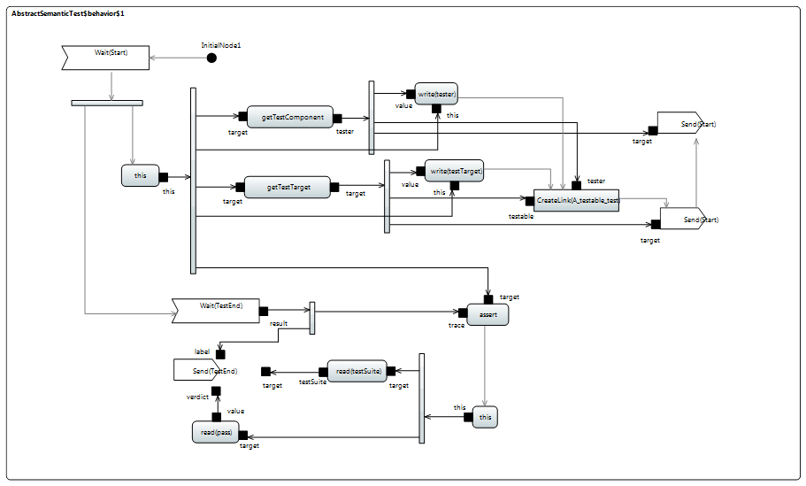Figure 9.2 - SemanticTest classifier behavior

SemanticTestSuite
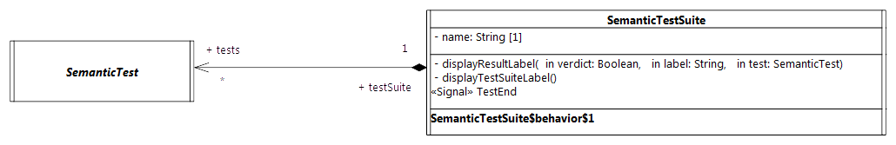Figure 9.3 - Semantic Test and Test Suite

Description
A SemanticTestSuite owns a set of SemanticTest. The execution of these tests is orchestrated by the test suite itself. Tests are executed one by one. At the end of each test the verdict is retrieved by the test suite that is charge of displaying the results. This is active class and is not intended to be specialized.
One can notice that it matches the concept of TestContext proposed by UTP. This class has the stereotype TestContext applied.

Attributes
- Name: String [1] – The name of the test suite.

Association Ends
- tests: SemanticTest [*] - the set of semantic tests that is handled by the semantic test suite.

Receptions
- TestEnd – The SemanticTestSuite class is able to received TestEnd signals.

Operations
- displayResultLabel(in verdict: Boolean [1], in label: String[1], in test: SemanticTest [1]) – A convenience operation to display the test result on a output stream.
- displayTestSuiteLabel() - A convenience operation to display the name of the name of the suite on an output stream.

Classifier Behavior
The classifier behavior of the suite encodes a sequential execution of the test known by the test suite. Each time a test (that was started by the test suite) terminates then the test suite gets notified. As soon as the notification (i.e., a TestEnd signal) is dispatched then the test result is displayed in the output stream chosen by the user. The classifier behavior of the semantic test suite is presented in Figure 9.4.

Protocol
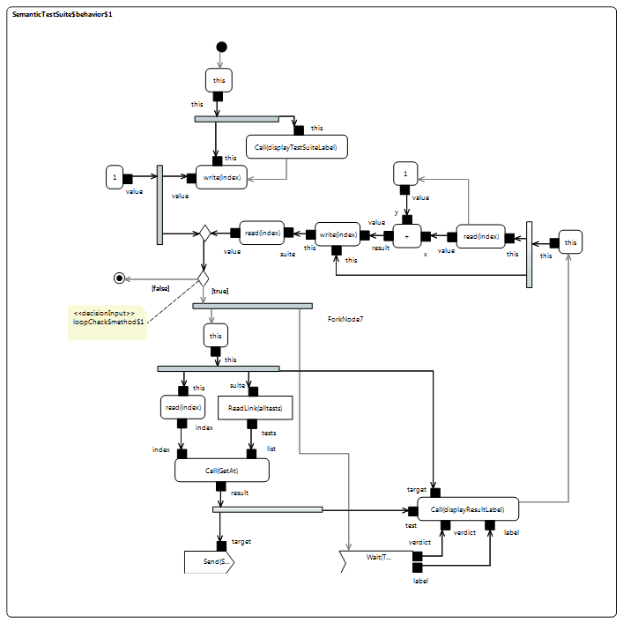Figure 9.4 - SemanticTestSuite classifier behavior
The Protocol package of the test suite has two subpackages: Messages and Events.
- Messages contains all signals used to communicate between the different active classes (see the model below).
namespace StateMachine_TestSuite::Util::Protocol;
package Messages {
/* -- Synchronization --*/
public signal Start {}
public signal End {
public trace: String;
}
public signal TestEnd {
public verdict: Boolean;
public label: String[0..1];
}
/* -- Synchronization --*/
/* -- Stimulations --*/
public signal Continue {}
public signal AnotherSignal {}
public signal Pending {}
/* -- Stimulations --*/
}
- Events contains the signal events (for the signals located in Messages) that can be directly used by triggers.
The following subclauses present the different signals and their usages in the context of the test suite.

Synchronization
These signals are used to synchronize executions of different active objects.

Start
The Start signal is used for to two purposes in the test suite context. First it enables the test suite to start the execution of a specific semantic test. Second it enables the test to start both its tester and its target. The modeling constraint for the SemanticTest, the Testert and the Target is that they must all register an accepter for the Start signal at the beginning of the execution of their classifier behaviors. Note that Start signal does not encapsulate data (since it has no attributes).

End
The End signal enables the Target to provide its controller (i.e., the SemanticTest) with a notification containing its execution trace. The semantic test takes advantage of this notification to compute the test verdict.

Attributes
- trace: String [1] – The execution trace generated by the state machine which plays the role of a classifier behavior for the Target.

TestEnd
The TestEnd signal enables a semantic test to notify its test suite that it has completed. This notification encapsulates two information: the test verdict as well as a label indicating in case of a fail the differences between the expected trace and the trace actually produced during the execution.

Attributes
- verdict: Boolean [1] – The verdict of test that is two say pass or fail encoded as Boolean values.
- label: String [0..1] – If the test failed the label presents the difference between the trace that was expected and the one actually produced during the execution.

Stimulation sequence
These signals (i.e., Continue, Pending and AnotherSignal) are used by the tester to stimulate the target (i.e. the system under test). None of these signals encapsulate data.

Tracing
At runtime the target is intended to produce an execution trace. This trace will be used to compute the test verdict by comparing the trace expected by the semantic test against the one actually generated by the target. The production of this trace relies on a small utility class TraceBuilder.
namespace StateMachine_TestSuite::Util::Tracing;
class TraceBuilder {
/*Record the trace as simple String*/
public trace: String;
/*Construction and destruction */
@Create
public TraceBuilder();
@Destroy
public destroy();
/*Add a new segment in the trace*/
public addSegment(in segment: String);
}
The execution information (state entered, behavior executed, etc.) which must be part of the trace are up to the designer of the test. To add a new information in the trace the designer must call the trace operation provided by the target. This latter will delegate to the trace builder. Such call to the trace operation must take place while the state machine is currently running. Consequently there four places at which the calls to trace might occur:
- The entry behavior of a state
- The doActivity behavior of a state
- The exit behavior of a state
- The effect behavior of a transition

Tests

Behaviors

Overview

Test Behavior 001

Test Behavior 002

Test Behavior 004

Transitions

Region

Event

Entering

Exiting

Exit

Entry

Choice

Other Tests

- Protocol State Machines
(informative)
  - Overview
Protocols state machines are intended to specify some constraints on sequences of interactions supported by an associated classifier behavior together with their expected outcomes.
According to the UML 2.5 specification, violation of a constraint specified by a ProtocolsStateMachine at run time shall result in an exception to be raised. However, since the fUML version upon which this specification is built does not support exceptions, it is not possible to define an executable semantics for ProtocolsStateMachines. Instead, the following section provides a precise interpretation of the UML semantics for ProtocolsStateMachines.
According to UML 2.5, this interpretation assumes the following restrictions:
- ProtocolConformance is excluded since the real conformance of one protocol to another depends the valid interaction sequences actually allowed be each of them and cannot simply be claimed.
- Protocols specify contracts constraining all the involved entities. ProtocolsStateMachines are given semantics only in the case where they control binary interactions. This specification constrains them to be associated with an Interface. Note: the fUML version upon which this specification is built does not support the concept of Interface but it is added by PCSC.
- There can be more than one protocol defined for given Classifier. The precise semantics specified below assumes that only one protocol is controlling a given interaction. ProtocolsStateMachines are constrained to be associated with a Port, which identifies an interaction point where the protocol applies. Note: the fUML version upon which this specification is built does not support the concept of Port but it is added by PCSC.
- Neither Operation::precondition nor Operation::postcondition are derived. Therefore, it is not possible to compute them according to the preconditions and the postconditions of enabled ProtocolTransitions they are associated with. Instead, this specification assumes that the constraints imply by an enabled ProtocolTransition is the result of a logical “and” between the preconditions and the postconditions, respectively, of both the protocol transition and its associated operation.
  - Abstract Syntax
    - Overview
The Figure A.1 shows classes related to protocol state machines in the PSSM StateMachines package. The diagrams correspond to similar diagrams in the UML 2.5 Specification. The following feature has been excluded from the PSSM subset:
- ProtocolConformance: this class is excluded since it is a declarative statement that can be derived from the actual definition of the involved ProtocolStateMachine.
    - Class Descriptions
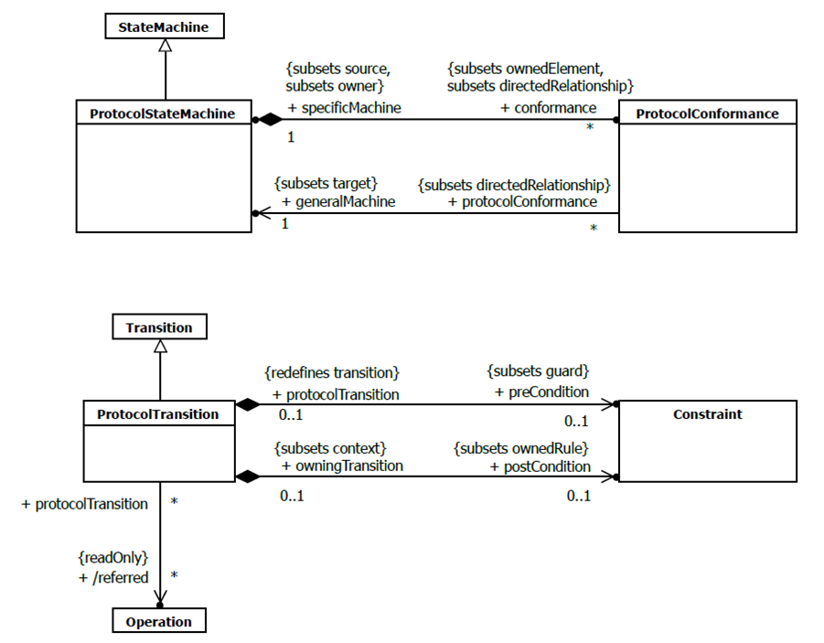Figure A.1: Protocol State Machines
      - ProtocolStateMachine [Class]
Generalizations
- StateMachine (from PSSM::Syntax::StateMachines)
Association Ends
- ♦ conformance : ProtocolConformance [0..*]{subsets Element::ownedElement, subsets A_source_directedRelationship::directedRelationship} (opposite ProtocolConformance::specificMachine)
Additional Constraints (from PSSM::Syntax::ProtocolStateMachines)
- PSSM_associated_with_port_and _interface
A protocol state machine shall to be associated with a port which shall either uses or provides an interface to which this protocol applies.
Port.AllInstances()->exists(p | p.protocol = self
and (p.provided->union(p.required)->exists(i | i.protocol = self))
- PSSM_no_conformance
A protocol state machine may not have any conformance specified
self.conformance->isEmpty()
      - ProtocolTransition [Class]
Generalizations
- Transition (from PSSM::Syntax::StateMachines)
Association Ends
- ♦ postCondition : Constraint [0..1]{subsets Namespace::ownedRule} (opposite A_postCondition_owningTransition::owningTransition)
- ♦ preCondition : Constraint [0..1]{subsets Transition::guard} (opposite A_preCondition_protocolTransition::protocolTransition)
- /referred : Operation [0..*]{} (opposite A_referred_protocolTransition::protocolTransition)
Operations
- referred() : Operation [0..*]
  - Semantics
    - Controlled Events
Interactions controlled by a ProtocolsStateMachine are restricted to event occurrences for which this state machine has at least one trigger defined. An occurrence of such a controlled event violates the protocol specified by a ProtocolsStateMachine if it is not explicitly allowed according to the current state of the protocol.
    - Protocol States Configuration
The initial state configuration of the protocol is defined according the initial Pseudostate of each active Region within the ProtocolsStateMachine. For each occurrence of an event controlled by the ProtocolsStateMachine which is not invalid, the corresponding ProtocolTransition is fired, which result in the target State to become the active protocol state.
    - Protocol Violation
A protocol violation shall result in an exception to be raised. It occurs in the following cases:
- An occurrence of a controlled event is received while it is invalid. That is: there is no enabled ProtocolTransition for that event for which the precondition is satisfied. In cases where that event is a CallEvent, this precondition is computed as a logical “and” between the ProtocolTransition::precondition and the CallEvent::operation::precondition.
- The postcondition of the protocol transition activated following the occurrence of a controlled event linked o the invocation of a BehavioralFeature is not met at when the execution of the corresponding method ends. In cases where that event is a CallEvent, this postcondition is computed as a logical “and” between the ProtocolTransition:: postcondition and the CallEvent::operation::postcondition.

The exact type and format of such a variable are of no concern here; implementers are free to chose their own.
To simplify the example, we assume here that there are no entry, exit, or do behaviors associated with any of the states.
See https://wiki.eclipse.org/Papyrus/UserGuide/ModelExecution

